Smart Pipeliner: Anonymous Export

You already know that it’s not easy to reach hyper-productivity and the precondition is to reach flow first, and to reach flow it’s very important to bring the organization into underload.
Underload means that you identify the constraint of the organization and then you have to insure that its fully loaded, but not overloaded and not underloaded. Therefore use this tool called Smart Pipeliner. The Smart Pipeliner is very useful but it has one big disadvantage. You have all your project data in it, very sensitive data, and that does not allow you to share it with others and get feedback
Therefore we designed a new function. It’s called anonymous export
Start by opening the Smart Pipeliner.
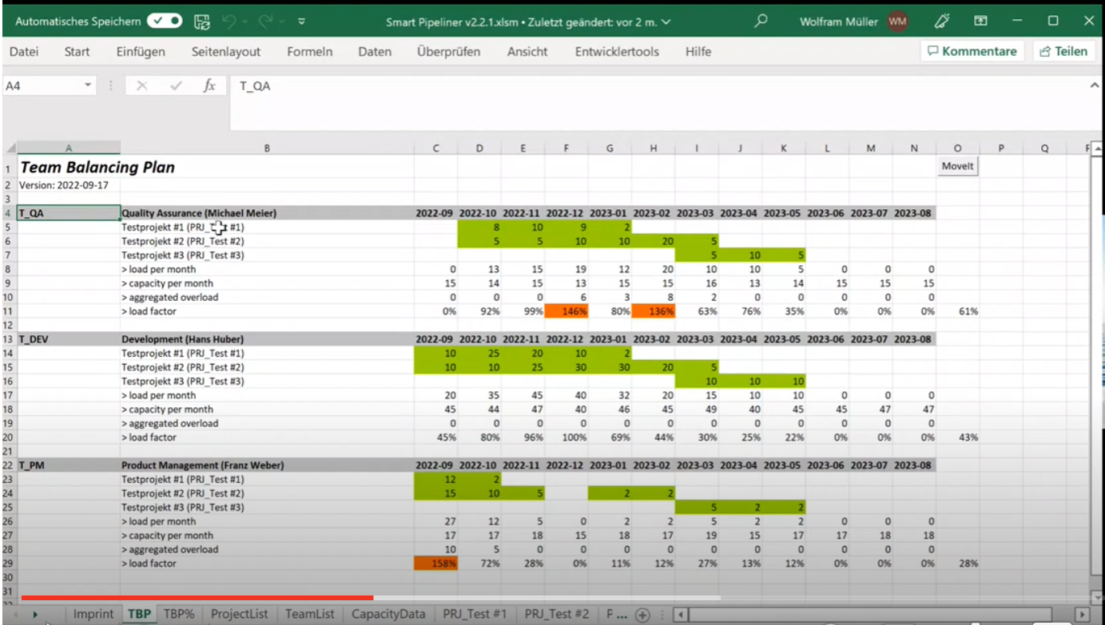You have the projects and the teams and they all have names. That’s all critical data.
If you look at the project list you also have critical information
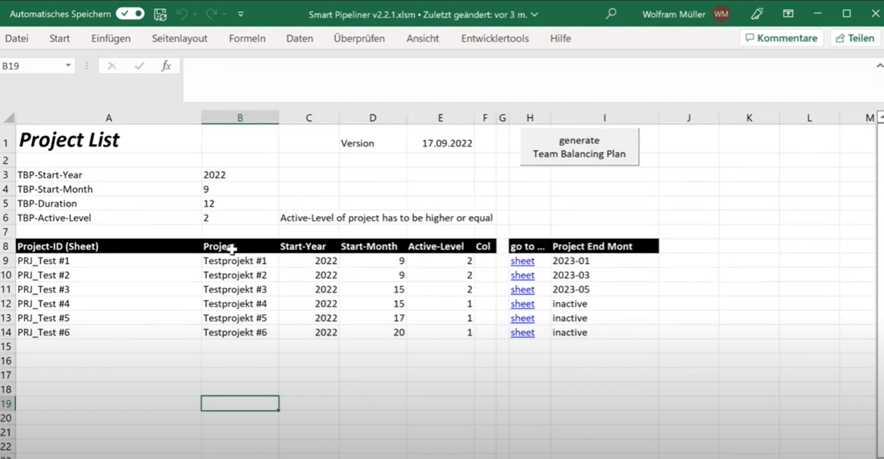If you look at the team list you see the Ids, the names of the teams, and the names of the people, and that’s all critical data.
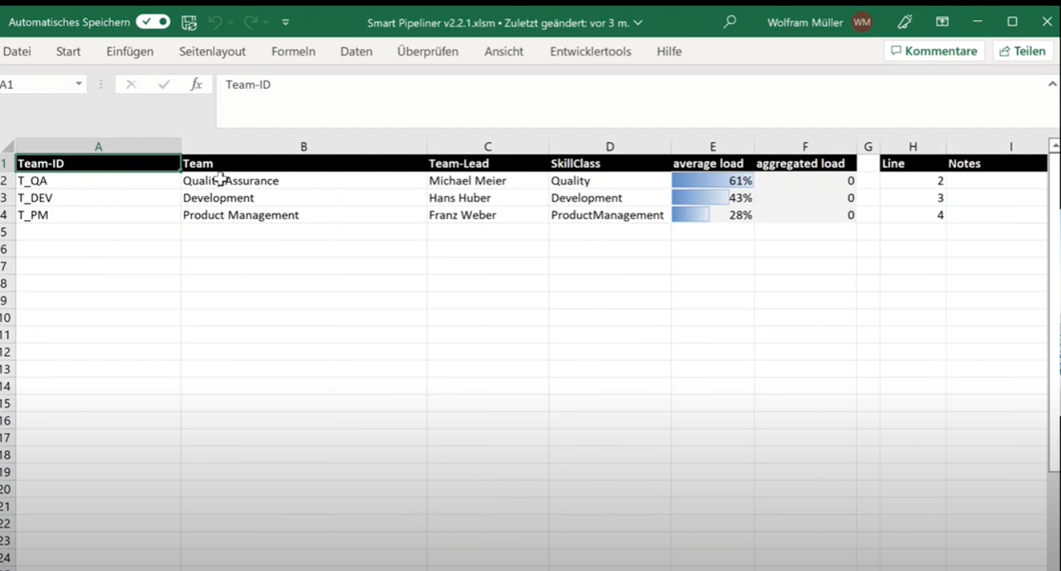So you can’t simply share the stuff. So the new function is a macro. If you look into the macros you will see a function called anonomize all
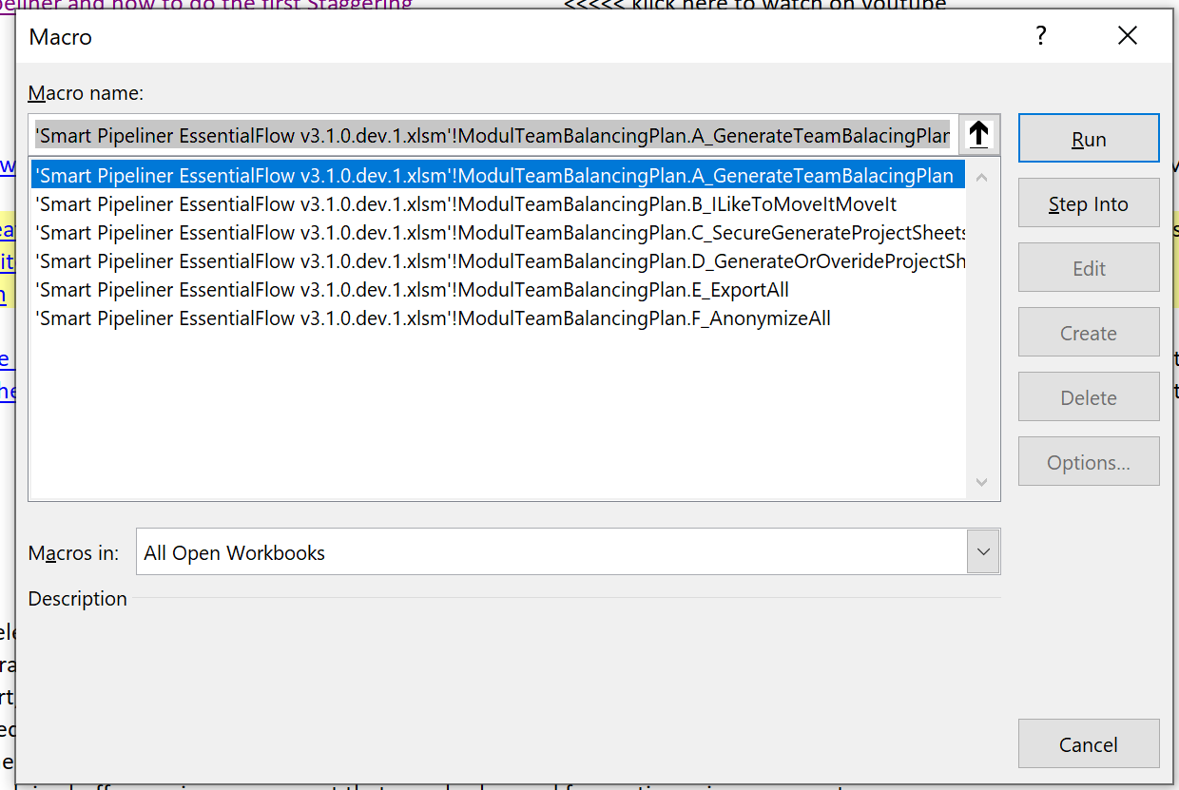
When you run this macro you will get a warning message.
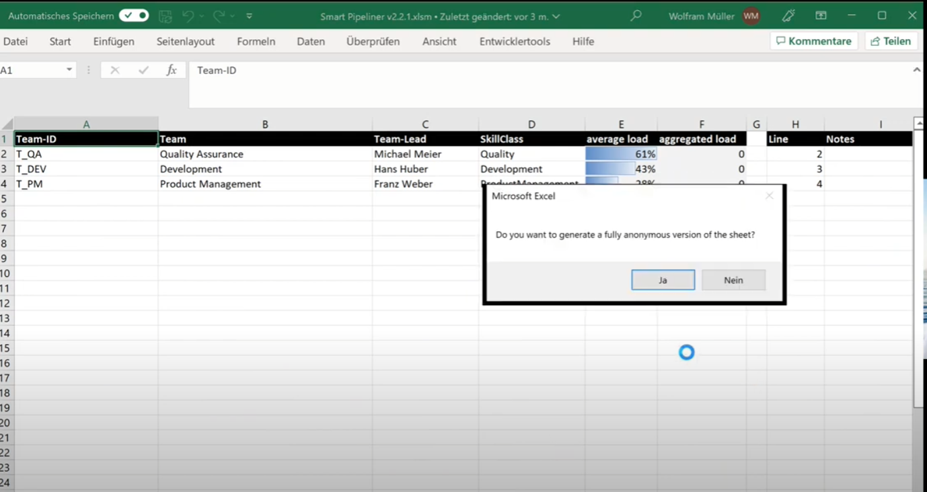
And when the macro finishes you will get a confirmation message.
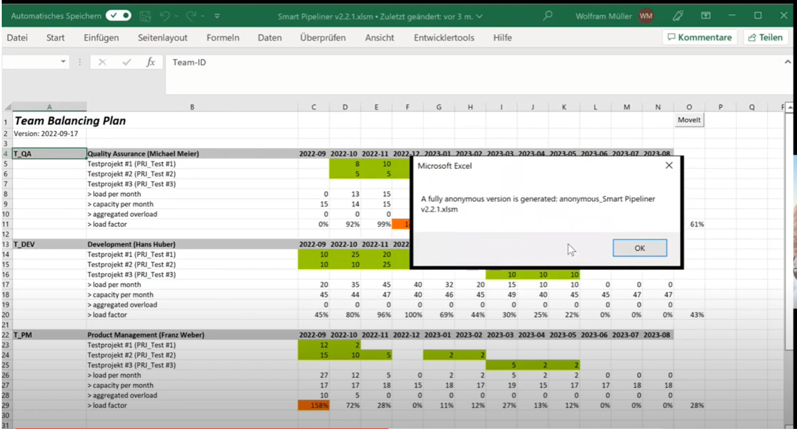
You will notice that nothing has changed in the original sheets.
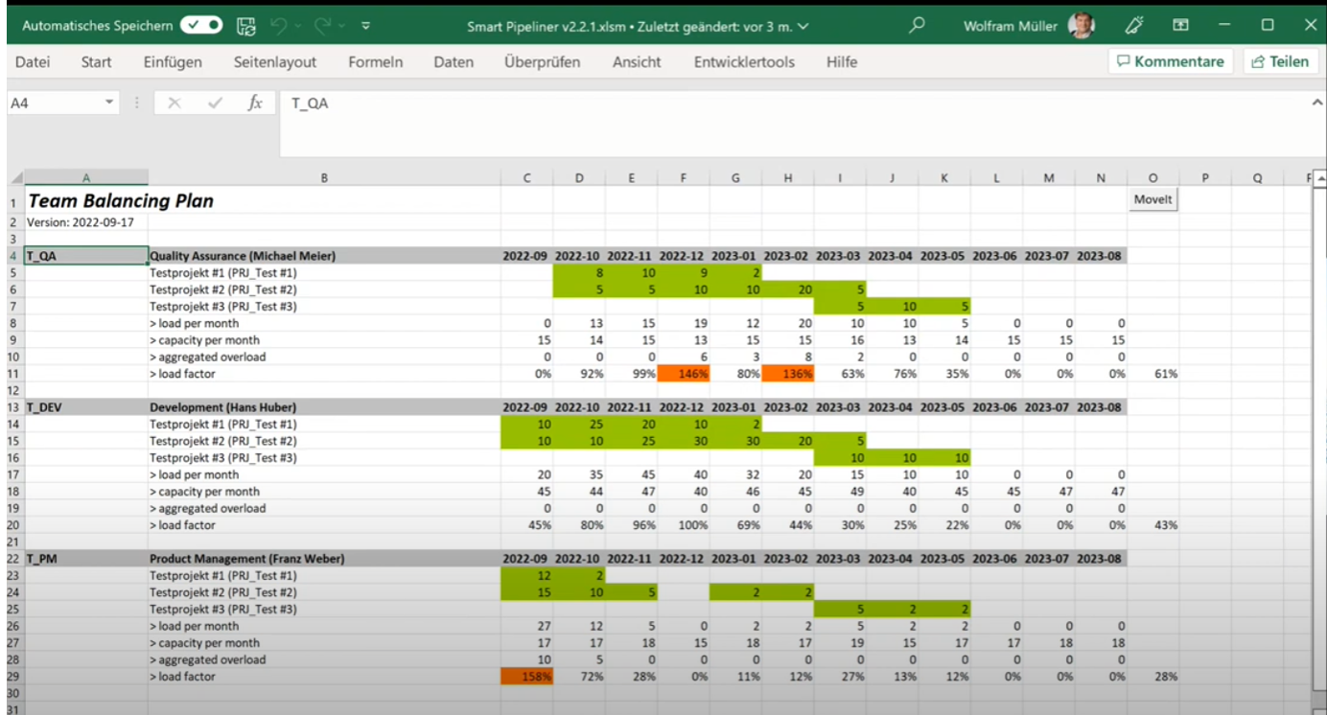
One new sheet has been added: anonymous lookup
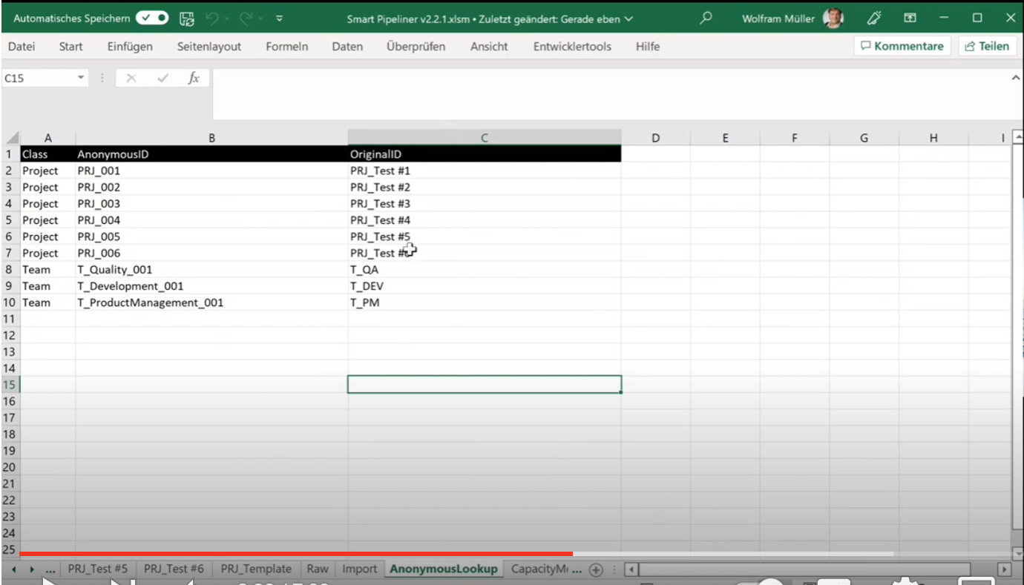
This sheet is a key that shows the values that were used to replace the existing values when the anonymous version was generated.
A new workbook will have been generated for the anonymous version.
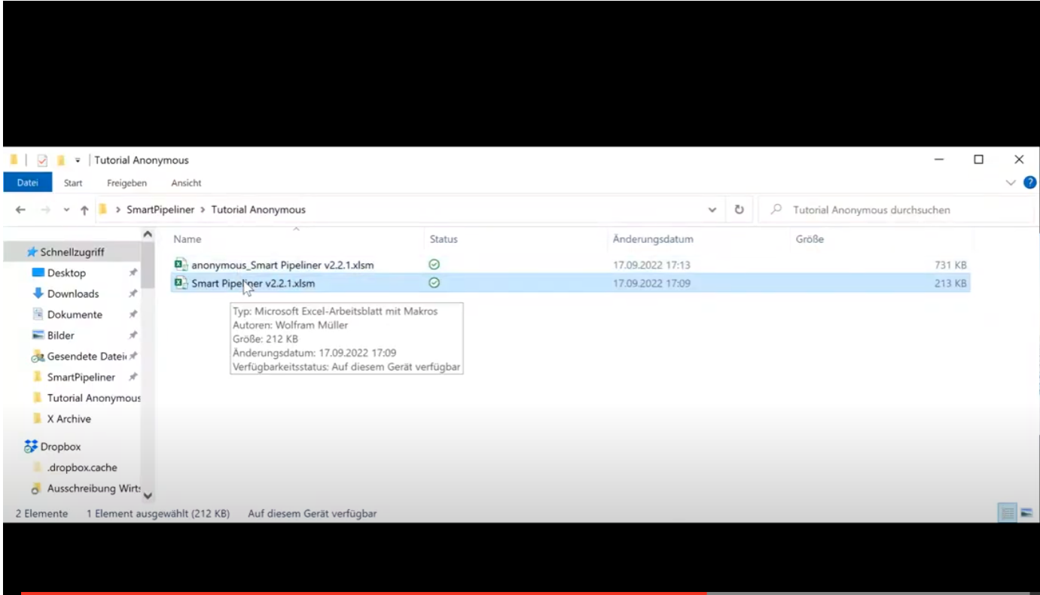
If we open the anonymous workbook we will see that project and team names have been replaced with the anonymous versions.
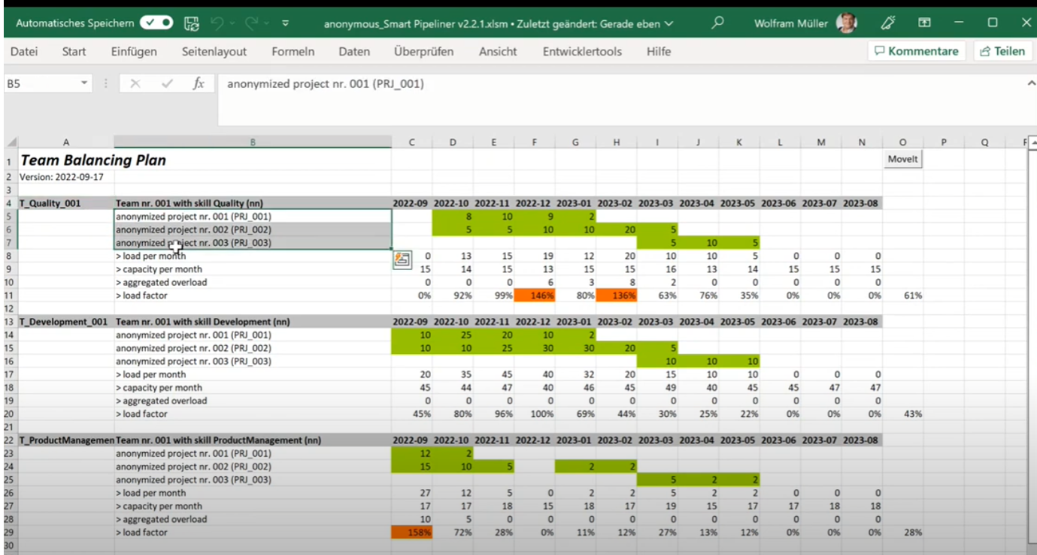
The names will be replaced in all the sheets.
If you had an import data set it is deleted
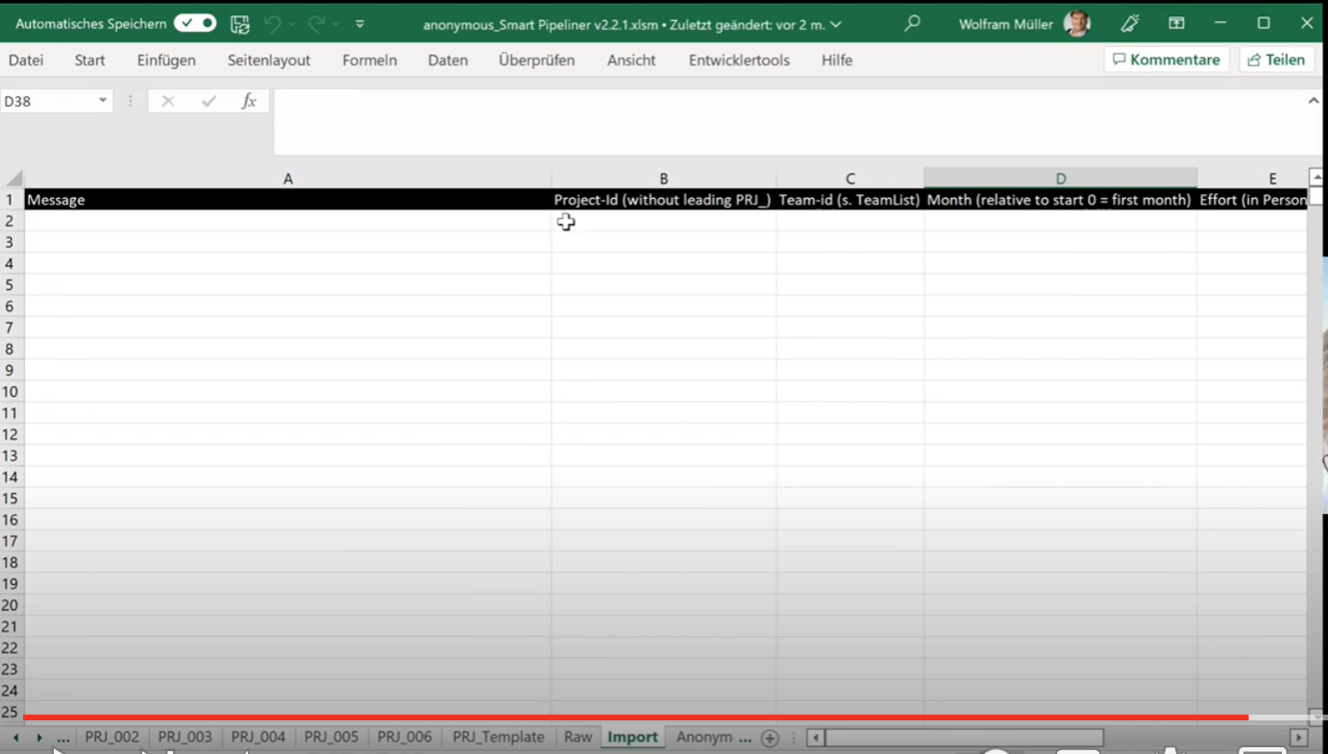
Even the translation table that mapped from the real data to the anonymous data is deleted
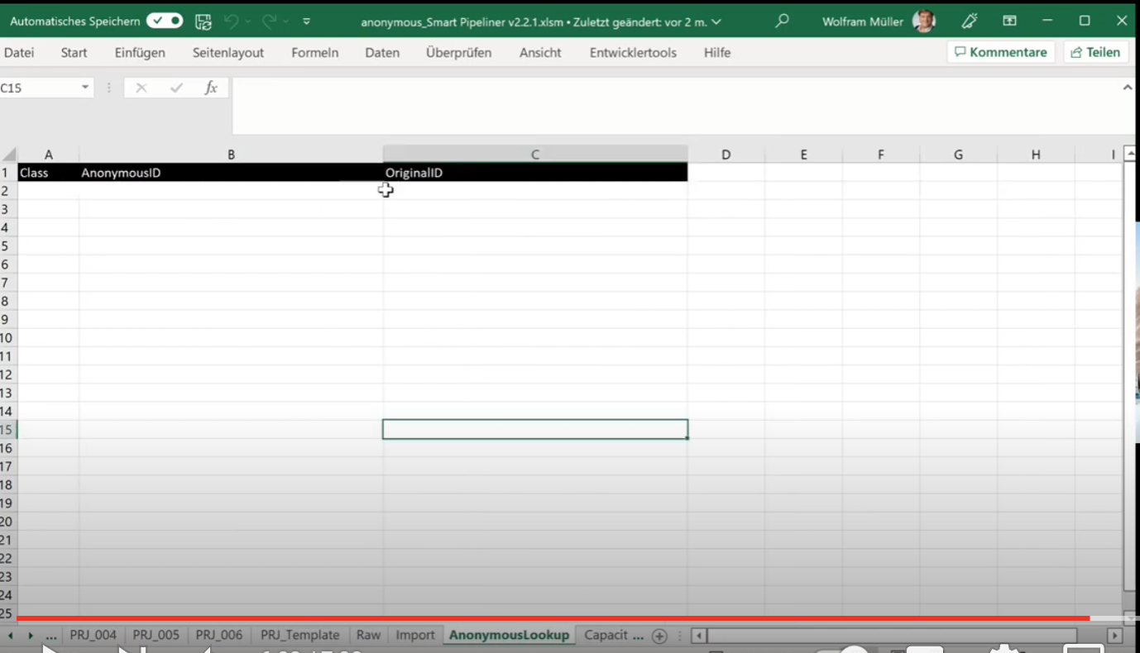
You can share this anonymous version with others to get feedback or ask questions. It’s a very good way to get feedback without showing real data or sensitive data.

