Smart Pipeliner

# Part Two: Balancing the pipeline and finding your constraint

The first step is to go to the Project tab and set all projects to start in the current month.

We will use month 9 for this example. We change the Active Level to 2 for all 6 projects, so they all will be included in the Team Balancing Plan

Then regenerate the Team Balancing Plan.

The effect will be as if every project is starting immediately.

You can see the average load for each Team in the “moving offset” column: Quality Assurance is 120%, Development is 43% and Project Management is 28%

The next step is to go back to the Teams Tab and reorder the Teams in the order of their average loads.

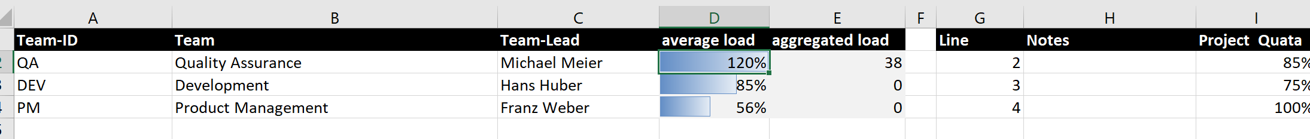

In our example the Teams are already in the correct order, with the highest average load first and then in descending order. This means that we will treat Quality Assurance as our Constraint. We can see that Quality Assurance is overloaded, with an average load of 120%

If you regenerate the Team Balancing Sheet you should see the team with the highest average load on top.

Quality Assurance only has a capacity per month of 14, so we move projects 3,4,5,6

We move projects 3 and 4 by 2 months and projects 5 and 6 by 4 months. This is called staggering.

There is a macro included that will stagger the projects with a moving offset. You might have to show the Developer tab in your Excel. You can do this by going to File/Options/Customize Ribbon and checking the “developer” check box.

Once you open the list of Macros, run macro B, ILikeToMoveitMoveit

This will stagger all the projects

We can see that month 10 for Quality Assurance is no longer critical because it no longer needs more Full Time Days that the Quality Assurance team has available.

If we look at the Project List tab, we can see that Projects 3 through 6 have new start months.

The sharp eyed might see that there is no 13th month for project 5 and 6, but the 13 allows all the necessary calculations to work.

Looking at the Team Balancing Plan we see that we still have overloaded months.

So we enter additional months to move them later in the schedule.

Then we run Macro B again…to MoveIt

We see that we have reduced the load for month 11 to an acceptable level, but we still have an overload for months 12, 1 and 2.

We are discovering that it is hard not to overload the constraint. We trying moving the offending projects again, this time by 2 months.

This finally brings the average load under 100%

Sometime you cannot avoid some overload. Month 12 is an example. What is important is that in the next month the load goes down, so the aggregated overload is reduced from 6 to 3. The same thing happens in month 2, again there is an overload. We try moving project 3 by 1 month

This redistributes the load.

Maybe we moved project 5 a month to much. We can enter a -1 to move it back a month.

After the move

We still have a high load for month 8, so we will move project 6 one month further.

After the move we have a more or less balanced sheet. There are peaks we cannot avoid, but by arranging the project start dates we make sure the project can recover from the peaks.

Just as the Theory of Constraints predicts, now that we have dealt with the load on the Constraint the other 2 teams also no longer have an overload.

It’s plain to see that balancing your flow is a matter of judgement and experience. One way to ramp up both quickly is to participate in the Essential Flow Round Table.

Export an anonymous copy of your Smart Pipeliner data and upload it to the Round Table to share with others. Ask questions and receive comments. Learn more and learn faster by working in a group.

<https://www.essential-flow.world/round-table/>

We can see a graphic representation of our balanced pipeline on the right hand side of the TBP% sheet

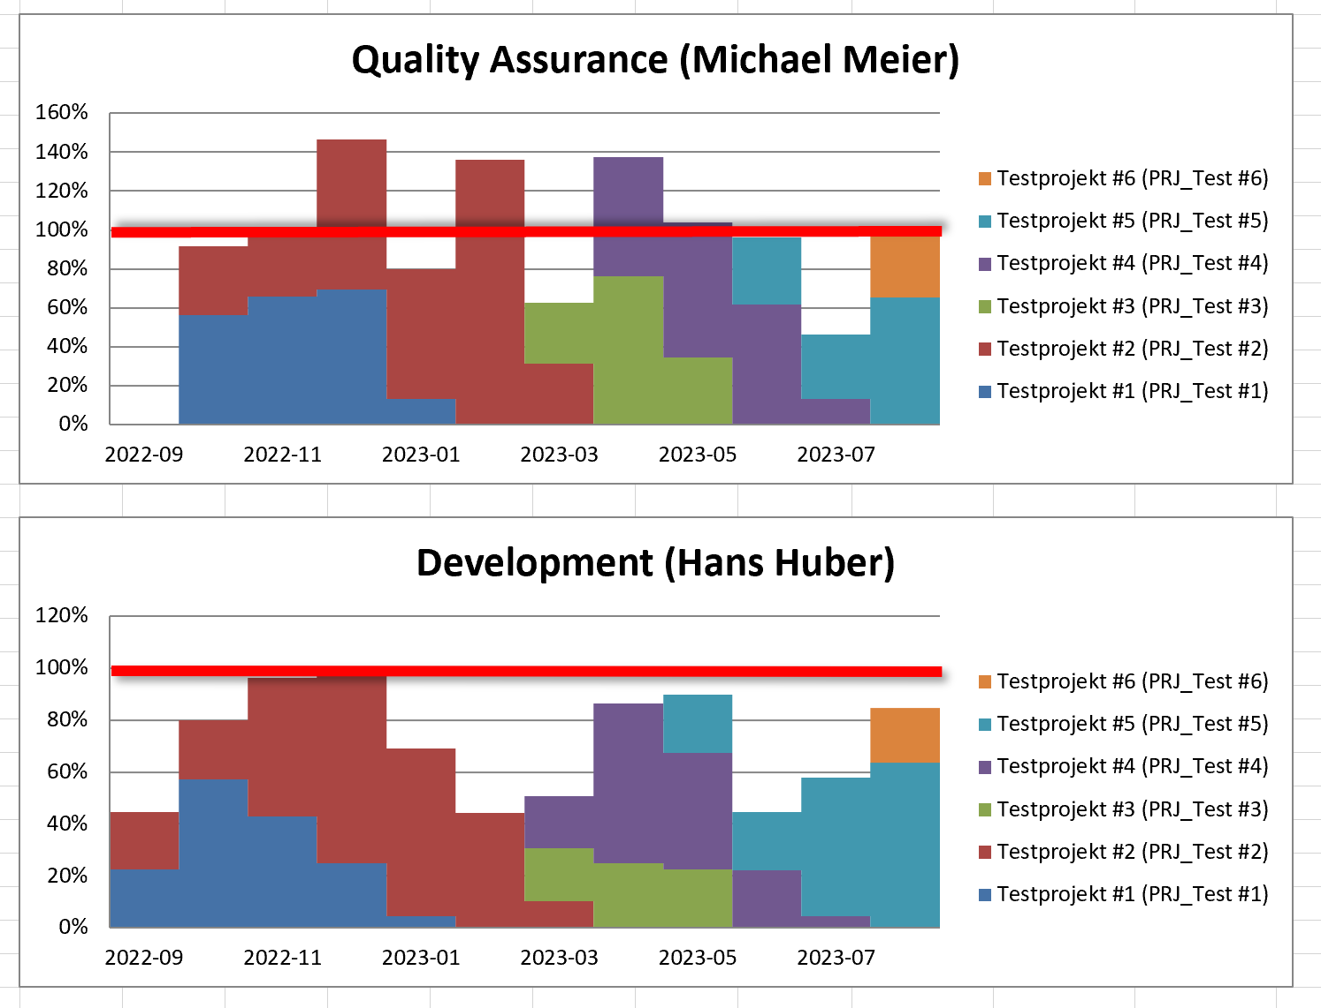

You can see that there are some peaks, but overall, the projects level out.

If you go back to the Project List tab you can see real end dates that you can commit to.

The sharp eyed will notice that we still have the bug in the Start-Year and Start-Month columns that gives us month numbers that are higher than 12😊

The over goal remains the same.

The aggregated overload should reduce to zero for all the teams by the end of the planning period.