# Smart Pipeliner 2.1.2

## The Capacity Model

The data for the capacity model is entered in the TeamList sheet.

Each team has a Project Quota.

The monthly data is entered as Full Time Equivalants. A 1 means that for that month that team has 1 FTE available for projects (there more be more people than that on the team, but here we are only interested in the effort available for projects).

Even if these people are available for projects they still do not devote all of their time to working on project work. The Project Quota is the percent of their time during the day that they are available for project work. The rest of their time they are doing daily work.

If we look at the CapacityData tab.

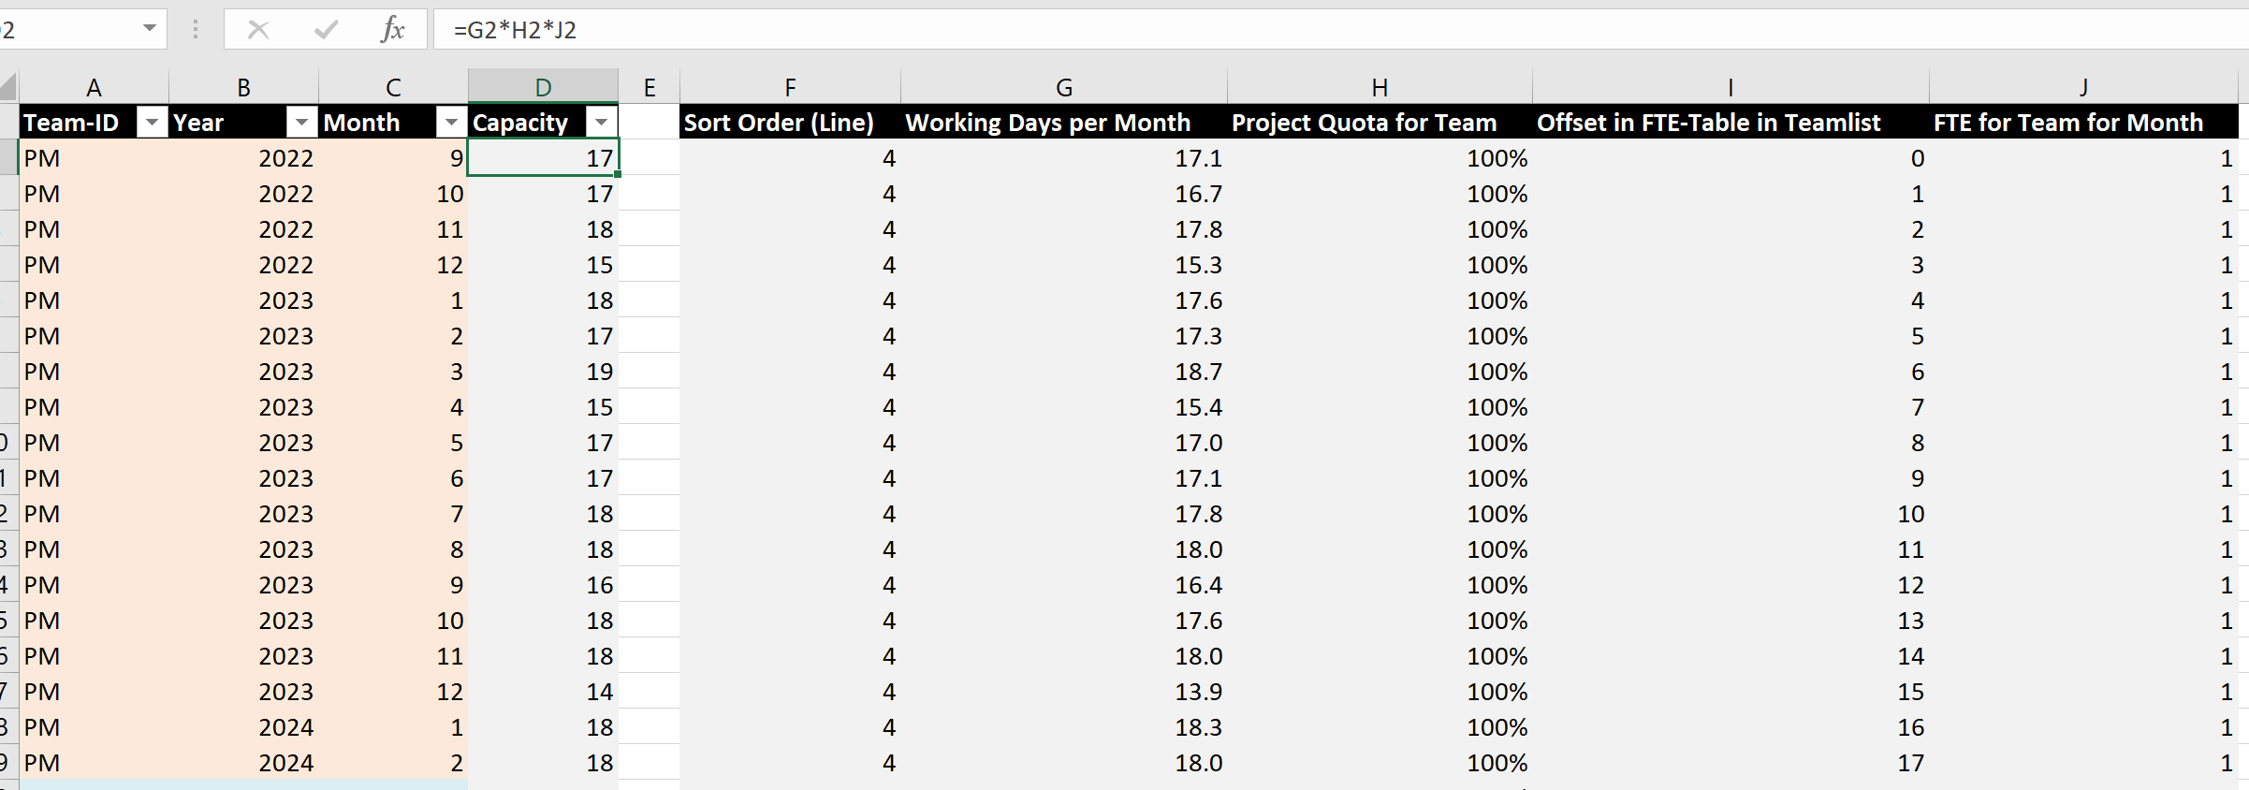

We can see that the capacity for each team for each month is calculated by multiplying the available Working Days per Month times the Project Quota for Team times the FTE for Team for Month.

For the PM (Project Management) team there is only one person. The capacity varies from month to month based on factors like the days in the month, or when they take their vacation or take sick days.

The next step is to develop the data on the Capacity Model sheet

The fields in yellow are those that need to be filled in.

The first number “205.0” is the typical average number of working days per year in Germany. You will have to arrive at a number for your location. There are many factors to be considered in arriving at this number, it cannot just be the number of working days per week times the number of weeks in a year. You need to consider vacations, sick days, other commitments, like company events, to arrive at a reasonable number for your situation.

The days in the Working Days column are also reduced by the number of bank holidays (or the holidays that your company allows). You can see that in Germany the days in April are reduced because of the number of holidays in that month.The Illness/Vacation column applies all these factors and calculates the Mean Brutto Work days for each Month

The final capacity calculated by this sheet is taken into the Team Balancing Plan

As the “capacity per month”

These calculations are somewhat complex. They sometimes make it easier for managers and executives to believe what you are showing. They can be more convincing that just apply some rule of thumb.

These calculations often start discussions with managers and executives about just how much capacity the teams have and can lead them to a more realistic assessment of how much load they can reasonably expect the teams to handle.