Smart Pipeliner

Part One: Setting up the Pipeliner
To reach hyper-productivity you first have to reach flow.
Often companies are overloaded. They have to reduce the work in progress first. And we are not talking about a small percentage, we are talking about 50/60/70 percent reduction.
They have to decide which projects stay active and which are postponed, and for managers this is a big challenge. They need data and transparency about the process.
Smart Pipeliner is all about helping the managers make those decisions about work in progress in an easy way.
The goal of the Smart Pipeliner is to produce a Team Balancing Plan that staggers the start date of projects to avoid overload.
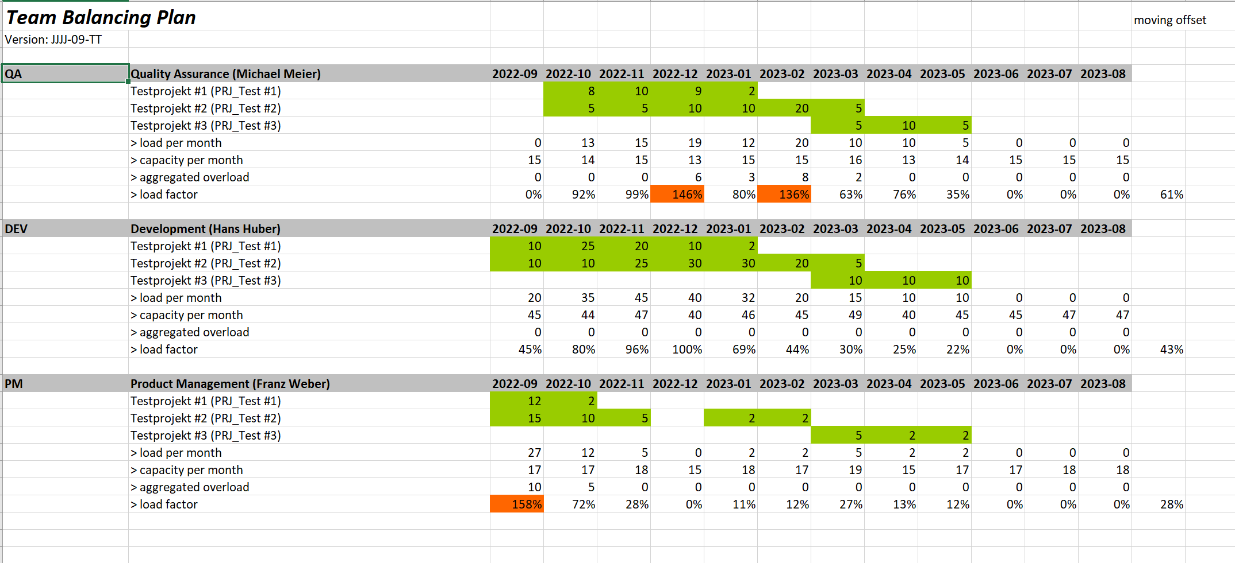
To get this result we have to put in some data.
Everything starts with the teams.
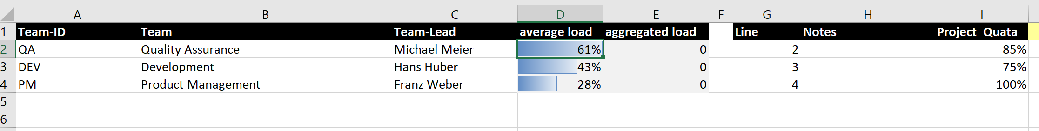
In this example we have 3 teams
We calculate everything in terms of persons and days of effort.
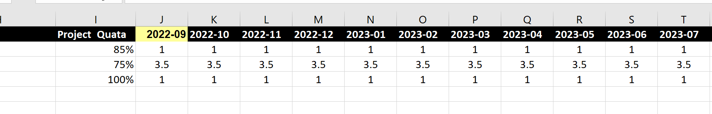
On the right hand side of the Teams sheet we enter the number of persons on each team for each month and the Project Quota, the percent of the team’s time that is devoted to project work rather than to daily work.
We are referring to “projects”, but they can be any sort of significant type of work: releases, projects, initiatives. They are all important deliveries, and they need some effort to accomplish.
The numbers of people available are Full Time Equivalents. Development shows 3.5 people. Possibly there are 5 people working on the development team but some of them only part time.
If you change the number of FTEs for a month the sheet will automatically propagate your change to future months
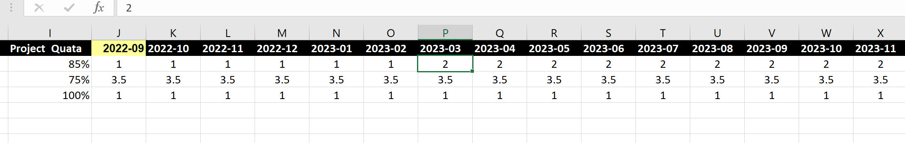
On the Capacity Data sheet this data is used to calculate capacities
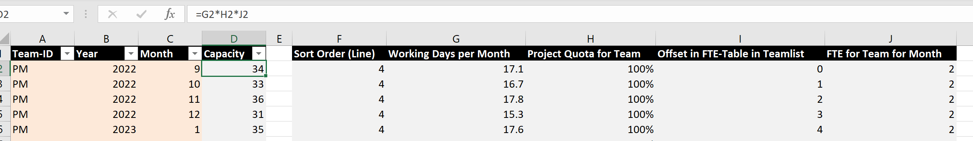
Here we see that the PM team has a capacity of 34 for 9/2022.
This is calculated by multiplying the FTE for Team for Month * Project Quota for Team * Working Days per Month
The capacity can rise of fall depending on things like vacation schedules.
The next step is to define the projects on the Project List sheet
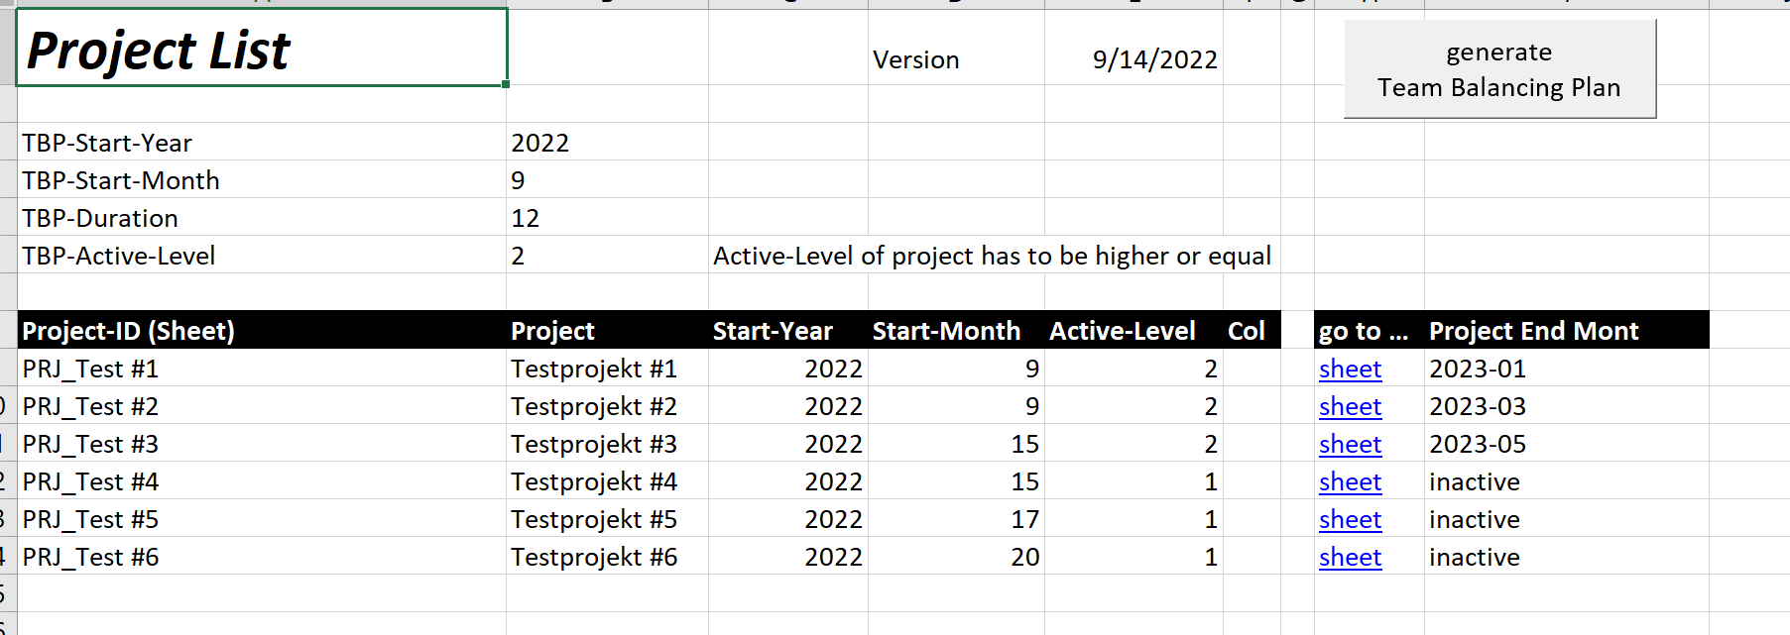
Every project has a name (in the Project column)
A Start-Year, a Start-Month and an Activity level (which will be used to assign priorities)
The number entered in the TBP-Active-Level field determines which projects will be included in the Team Balancing Plan. Only Projects whose Active Level is equal or higher than the TBP-Active-Level will be included in the calculations.
The Team Balancing Plan starts on the defined year and month and is calculated for the number of months that you enter as the TBP-Duration.
Projects are loaded into the pipeline in the Team Balancing Plan in the order that they are listed here. These sample projects are numbered, but it is the order in which they are listed that counts, not the numbers. Changing the order on this sheet will change the order during calculation of the Team Balancing Plan
Clicking on one of the “sheet” links in the go to column will take you to the sheet for that project. The sheet names are listed in the Project-ID column.
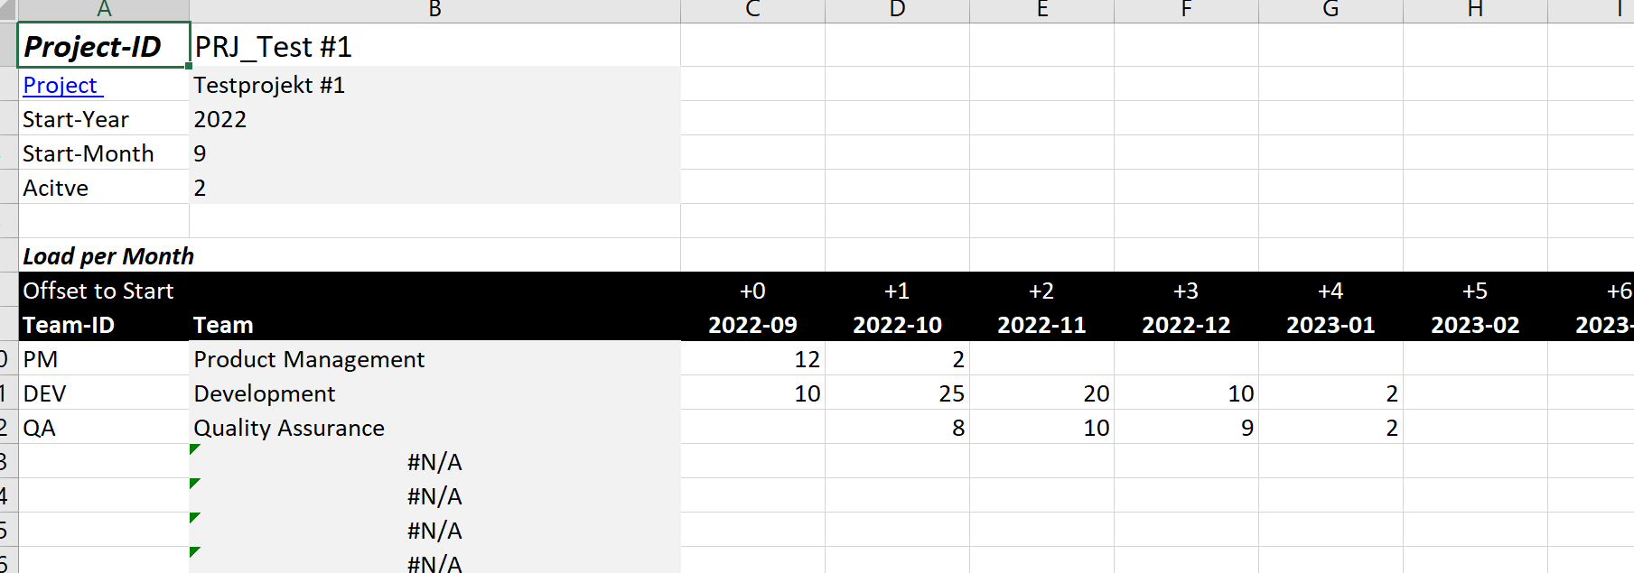
The year-month columns show the Full Time Equivalent days that are need from each team. The +0 column is for the first month of the project, regardless of the calendar month it starts in. The +1 column is for the second month of the project and so on.
Calculate the load as if you had resources available. Any balancing will be done with the Team Balancing Plan is calculated. Each individual project sheet should show the fastest way to do the project as if it were the only project being worked on.
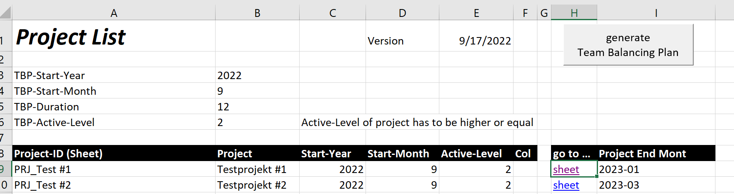
When you have entered the project data and the individual project plans you can go back to the Project List and click on the “generate Team Balancing Plan” button. The plan will open in a new sheet
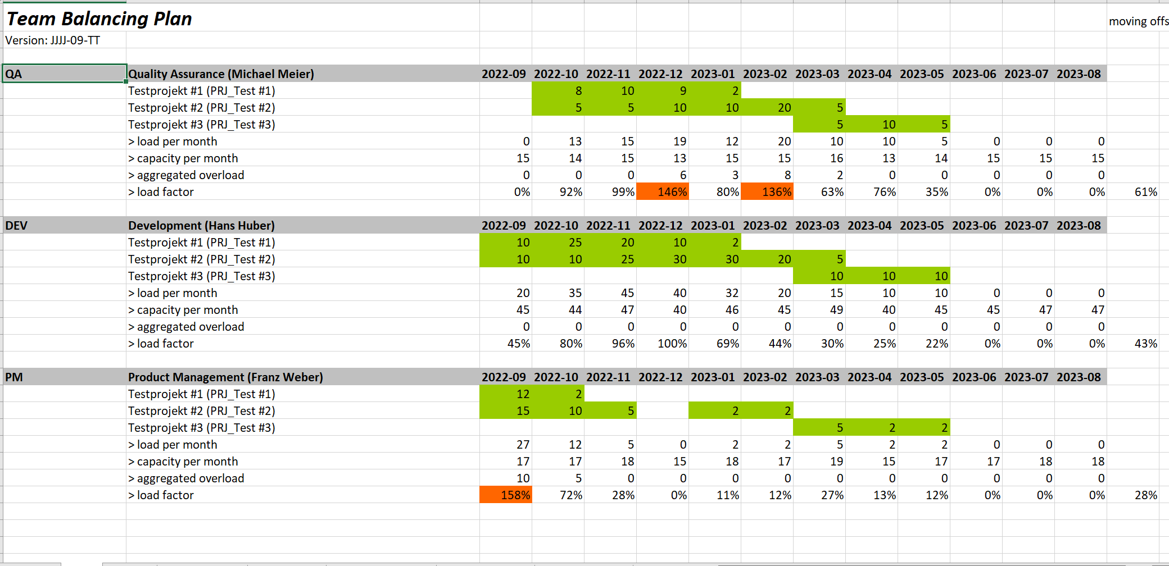
This sheet extracts the load information for each team and enters it in the order that the projects
If you look at the load per month and, capacity per month rows you can see how the aggregated overload and load factor columns are calculated. For example we can see that the QA team is overloaded in Dec and Feb and the PM is overloaded in Sep.
The aggregated overload is the days of effort that need to be added to the monthly load. We can see that for QA there are six extra days in Dec. QA is not overloaded in Jan so they can reduce the aggregate to 3 days, but they are overloaded again in Feb so their aggregate goes back up to 8. The goal, of course, is to have 0 days of aggregated overload so the team can take up new work.
On the right hand side of this sheet you can see a graphic representation of the teams and their commitment each month to each project.
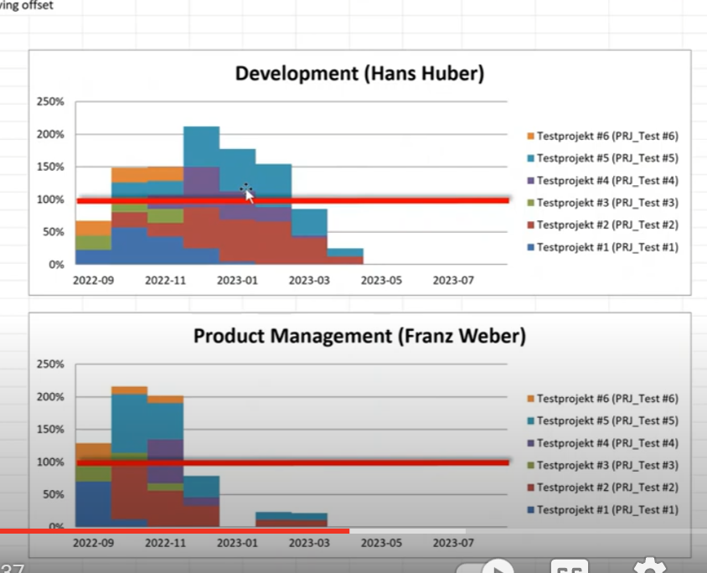

This is the end of part one. The next question is how you can balance your pipeline, how you can find your constraint.

