Smart Pipeliner 2.1.2

Bulk Uploads of Project Data

You can do a bulk import of project data using the Import sheet.
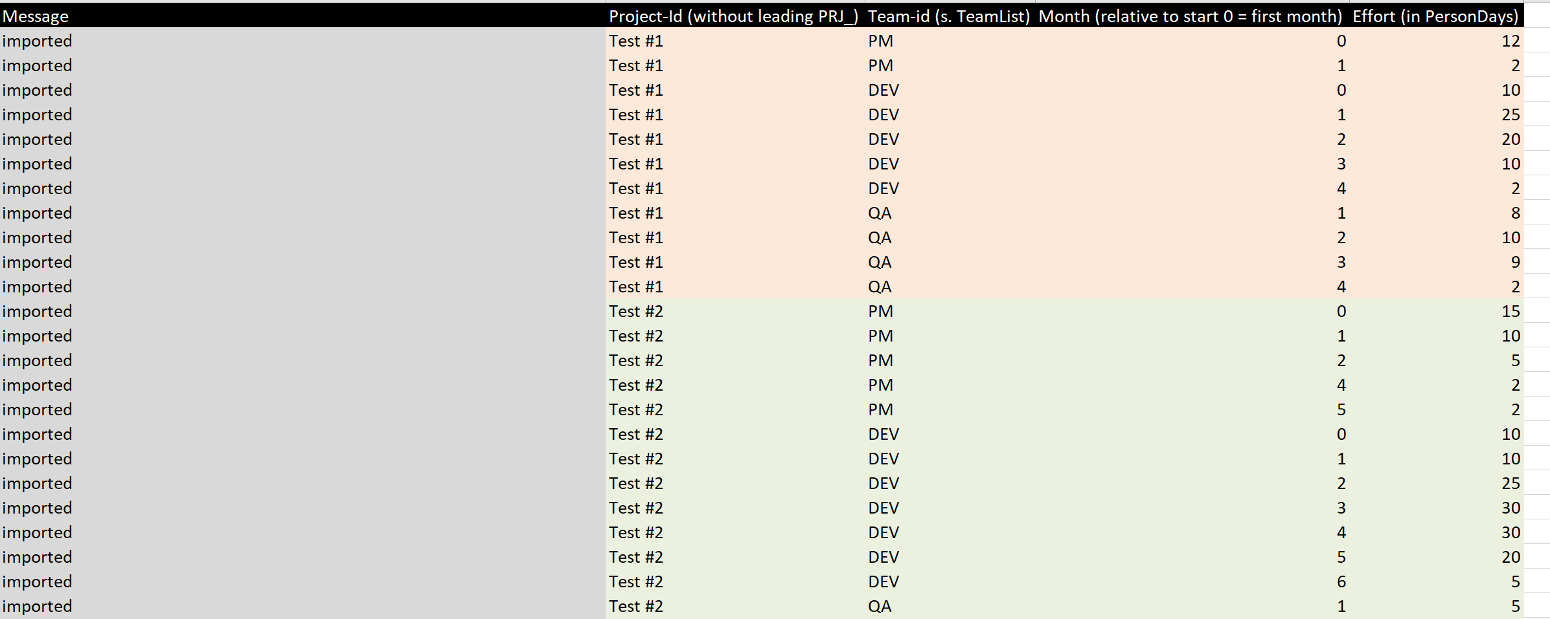
Note that the Project Id and the Team Id column should match the values on the Project List sheet
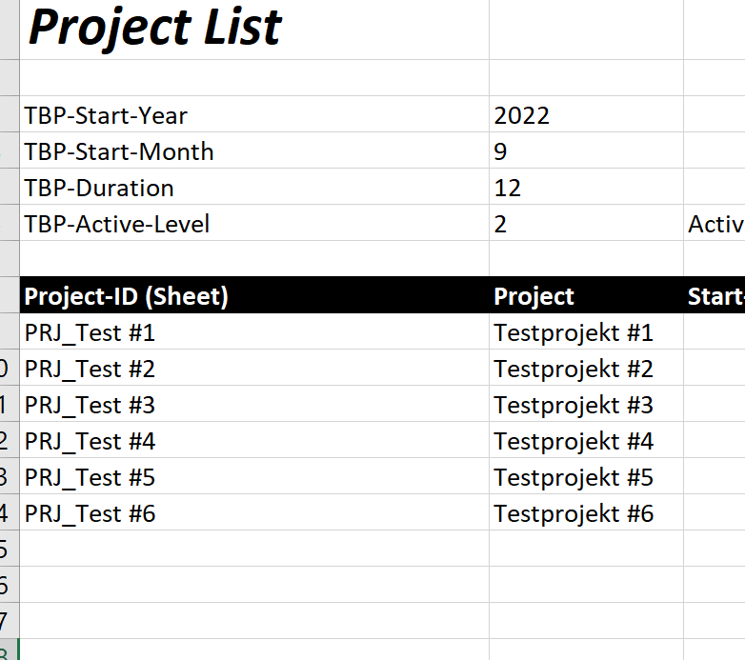
The Project Ids are entered in the Import sheet without the “PRJ_” prefix.
And the Team List sheet
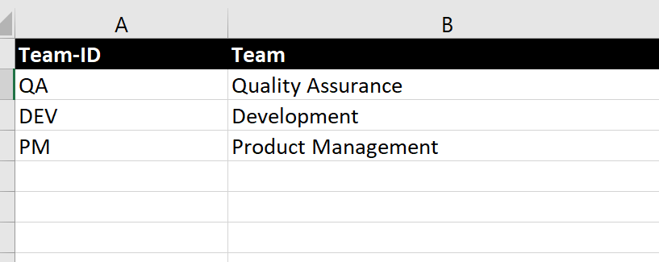

When you have entered your data in the Import Sheet you run the import using the macro “D_GenerateOrOverrideProjectSheetsFromImport”
If the macro runs into problems you will find error messages at the bottom of the sheet after you have processed the data
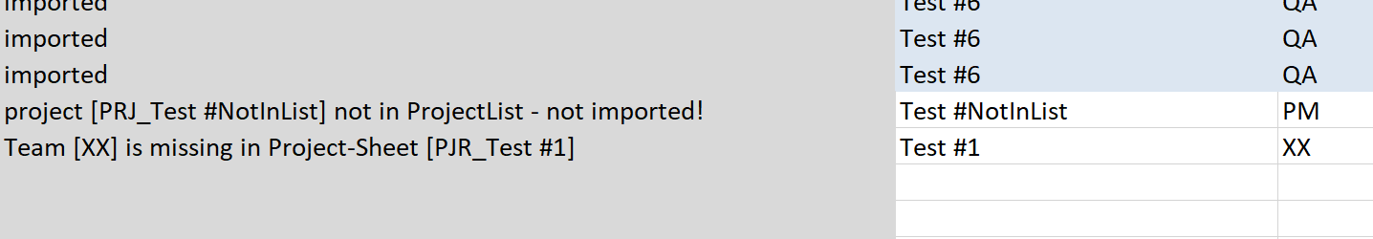
If there are Project or Team Ids on the Import sheet that do not match the Ids on the Project List and Team List Sheets you will get an error message when you process the import.
If this happens you can correct the errors are rerun the import by using the macro “C_SecureGenerateProjectSheetsFromImport”

